BIBLICAL MANDATE  i) Acts 16: 15 He (Jesus) said to them, "Go into all the world and preach the good news to all creation. " (NIV);  - Matthew 28:14 And this gospel of the kingdom will be preached in the whole world as a testimony to all nations, and then the end will come. (NIV);  - Acts 13: 47-48 "For so hath the Lord commanded us, saying, I have set thee to be a light of the Gentiles, that thou shouldest be for salvation unto the ends of the earth. And when the Gentiles heard this, they were glad, and glorified the word of the Lord: and as many as were ordained to eternal life believed." (KTV). | - Board Members  BIshop V. g. lambe, sr. –  general overseer  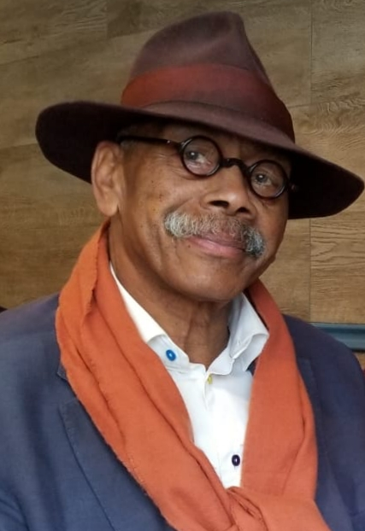  denton e. outerbridge – president  PHILIPPINES CONTACT  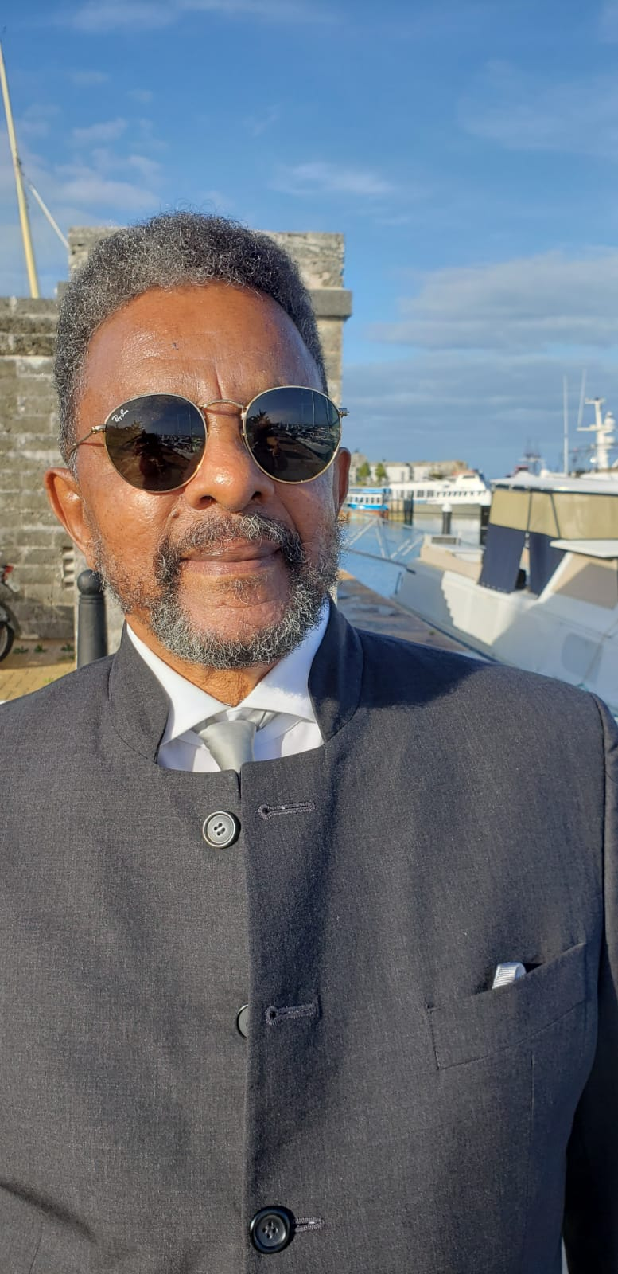  elder ryan wilson – vice president  haiti contact  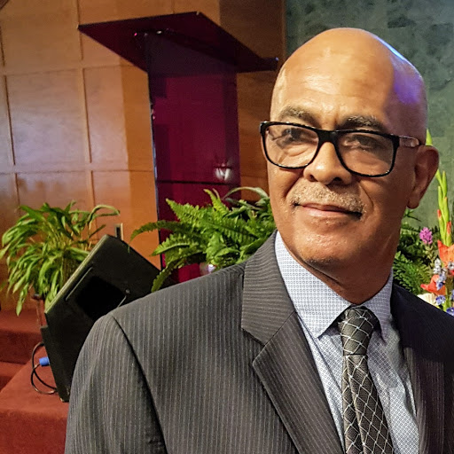  natalie simmons – secretary/treasurer  sri lanka contact  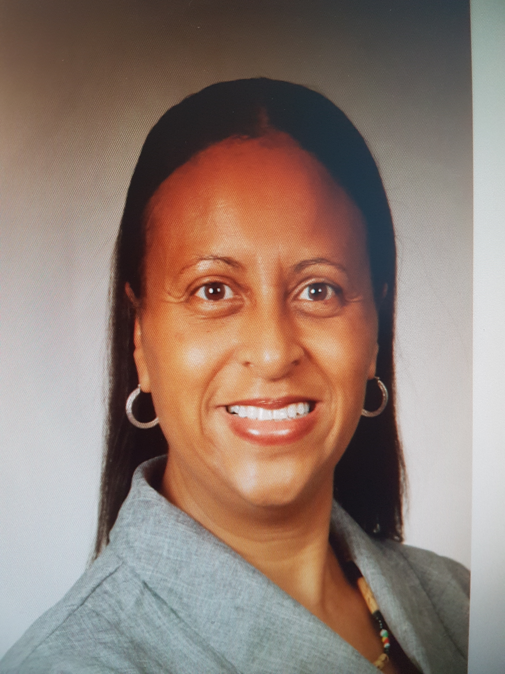  elder ruth ann lambe  ghana contact  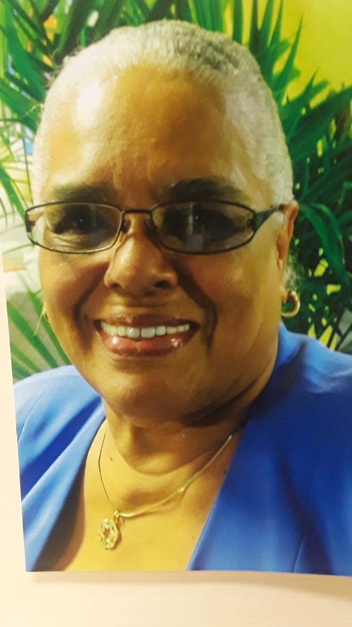  andrea pitcher  kenya contact  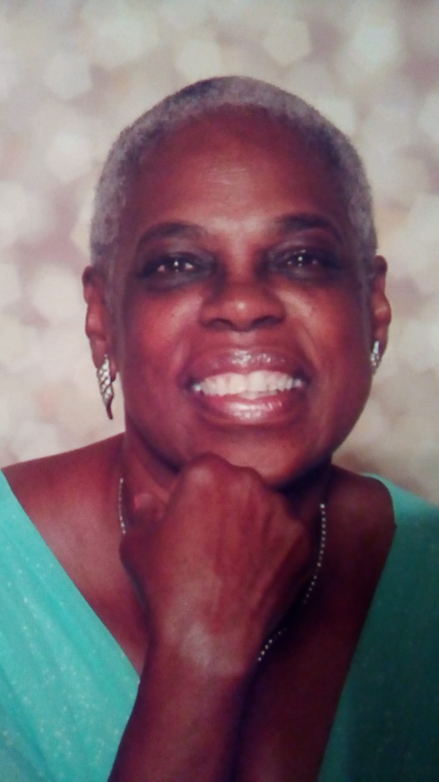 | 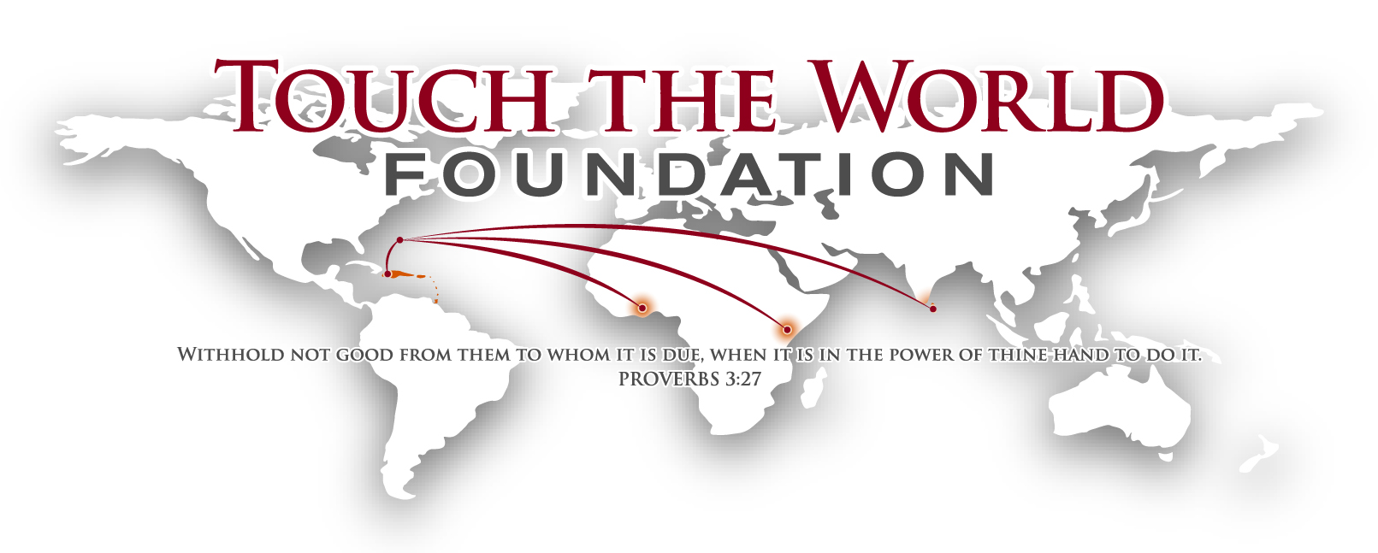  Touch The World Foundation IS THE Missions Arm of The First Church of God, North Shore, Bermuda  STATEMENT OF PURPOSE  To Promote interest and create an awareness of the importance of worldwide missions’ work. To be proactive in approach by evangelistic and benevolent ministries.  To Provide the necessary resources to missionaries and other related organizations, both local and global; to include the necessary tools for equipping, the financial support and prayer support for effectiveness and manifestation so that the good news of the gospel of Jesus Christ can be spread throughout the whole world.  To Position through awareness, interest, training and equipping of persons to the commissioning of short and/or long-term missionaries, being supported financially and otherwise by the Church and TTWF.  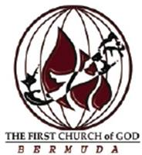
- Regularly Supported International Missions  Ghana - This is a privately-run school for students aged 8 to 13. We assist them with salaries for the teachers and in one case the building of a new school building.  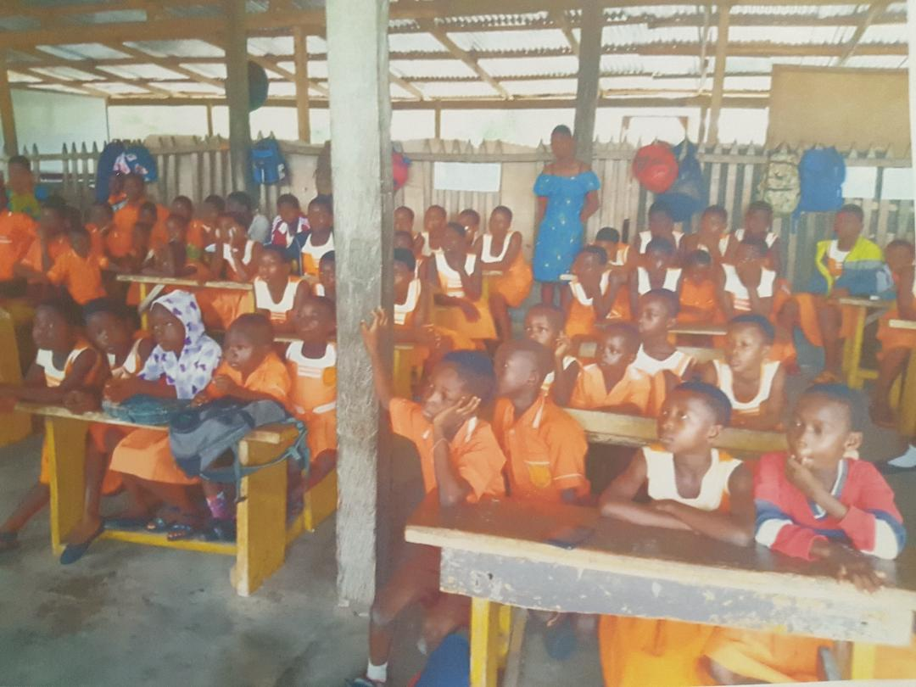  Haiti - Regular support is sent to an established facility at the Mission De L’Eglise De Dieu Reformee in Saintard, Haiti which heads up works to the needy and distributes goods to various pastors throughout the country. The leader of that work Sis. Phyllis Newby is responsible for establishing more than 200 churches in Haiti.  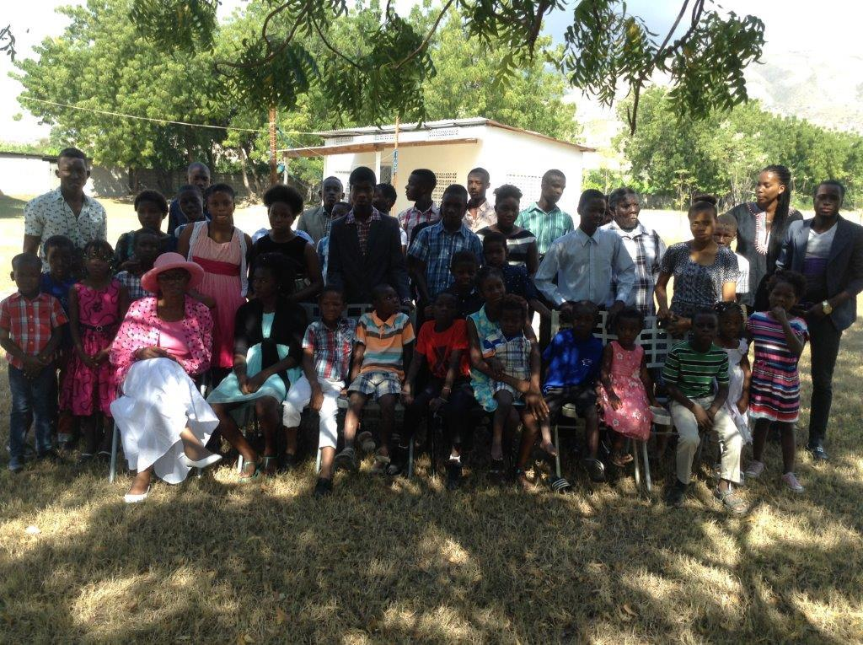 | Kenya (Molo Street Children’s Project) - Our finances here assist with the housing, schooling, and feeding of children who lived on the streets of Kenya.  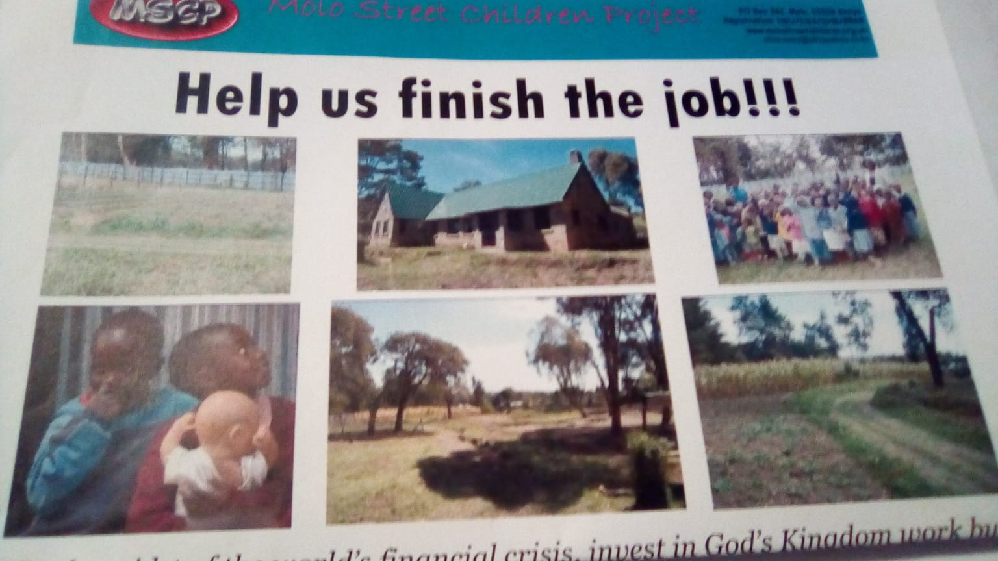  Sri Lanka (Shepherd’s Heart Children’s Home) - Currently, they have 18 girls; out of that, 8 are from other children’s homes that have been closed. Our efforts here are dedicated to 8 specific children we support to ease the burden of the costs of attending school.  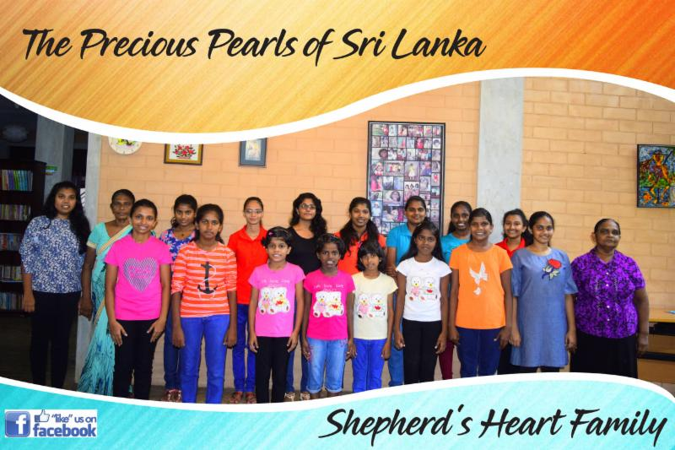  To do justice to the fatherless and the oppressed, that the man of the earth may oppress no more (Psalm 10:18).  ONE IN CHRIST MINISTRIES  (PHILIPPINE MISSION)  OCIM’s goals are to share the Gospel of Jesus Christ to the children and youth in far-flung areas in the Philippines; to disciple them and nourish their faith in Christ; to provide funding to benefactors who pursue college or a degree/ to provide training for teachers for Sunday School and yearly Vacation Bible School. | - Local Missions  - Outreach  Christmas Hamper Program  In 2018 TTWF partnered with our Food Bank Ministry to distribute Christmas hampers to over 50 seniors and needy families.  grocery vouchers  TTWF assists needy families throughout the year by providing grocery vouchers on an as needed basis. If you or some other truly needy families need food, please reach out to Elder Ruth Ann Lambe.

